**The battle of the neighbour hood**

**Introduction**

The cosmopolitan city of Bangalore is one of the most progressive cities in India that is blessed with a year-round balmy climate. The uber-cool bars and the quirky microbreweries make this city the most visited tourist destinations in India. If you’re craving a craft beer and would like to know the best breweries in B-town then look up our Bangalore blog that is perfectly curated to cover all the essentials you need to know before planning a trip to Bangalore. Explore the culinary scene, and lots more through these blogs about Bangalore and know the best places to visit in the ‘Garden city of the South’. Bangalore is blessed with green spaces and a striking Victorian architecture that will entice you to book a trip and enjoy the beautiful facades of this city. The modern city of Bangalore will give you world-class sights, quirky cafes, and top notch dining experiences. What’s more? You can only find by scrolling through the Bangalore travel blog that will ensure you have the best of experience in one of the largest cosmopolitan cities of India. Plan an exciting vacation with your friends to have the best time of your life explore the Silicon valley of India.

Bengaluru city has always been helpful for the people, be it with IT or any industrial works.

This is one of the best recommended city in India because,

* The society is great
* There are a lot of like minded people
* 100’s of job opportunities to work on.

**Business Understanding**

Bangalore is one of the most popular cities in the world and it is also known as the Silicon valley of India. So, this is the city with hundreds of opportunities . A restaurant is a business which prepares and serves food and drink to customers in return for money, either paid before the meal, after the meal, or with an open account. Bengaluru is famous for its excellent cuisine ,IT field. It's food culture includes an array of international cuisines influenced by the city's immigrant history.

In this part I have exploered,

* What are the best food options available
* Which sector of technology is good
* Which are some most common venues?

**Target Audience**

* My main target audience will be the one who are new to city
* The one who are planning to shift to this city
* Especially non residents

**Data Collection**

The data collection for this was done through a website , where I get all the pincode for all the cities in India.

With the help of beautifulSoup, I have made 3 columns

* Neighbourhood
* Pincode
* District

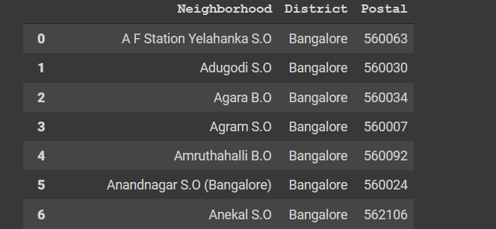

**Methodology**

3.1 Data Collection:

• Bangalore pin code were scraped from https://finkode.com/ka/bangalore.html • We used Foursquare API to get the venues around the hostel.

• acquired the latitudes and longitudes data by using Geocoding API from google cloud.

Using data preparation methods and normalising the provided json, I first performed exploratory data analysis to determine if the given dataset is trustworthy or not. We may directly extract data from the provided site using the BeautifulSoup package, as described previously. After receiving the data, I utilised the Google Maps Geocoding API with the appropriate credentials to find the latitudes and longitudes.

Secondly, I utilised prescriptive analytics to aid identifying a great spot to reside in Bangalore. I'm going to utilise clustering (K-Means). I'll look for the most common venue of a certain spot where we / the people may truly live in luxury with all of the conveniences available in the area.

**EDA(Exploratory data analysis)**

First, we have to gather the places as the dataset regarding the Bangalore is not easily found. So, I have acquired the data from the sites mentioned above and filled it with latitudes and longitudes using the Geocoding API from Google Maps.

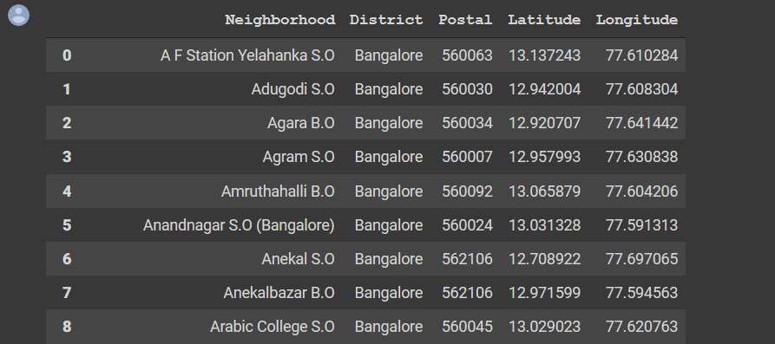

To access the venues from the exact pin code address we need to use the FourSquare API. FourSquare API allows us to access the venues and most common venues based on the people’s ratings and contact numbers and a lot more. We can use this for acquiring the data regarding the neighborhood places for the amenities and such. To activate the FourSquare APi, we need to use the credential ID and credentials. To get those details, we must first log in or register. I obtained the data set since we want the category table from the pin code.

After obtaining the data set, save it in a different data frame to avoid losing the original data set. For the prediction analysis, the investigated dataset will be transformed into one-hot encoding, therefore we will convert it. The below are the datasets which are converted into one-hot encoding I.e. acquired from the explored data frame.

One hot encoded data

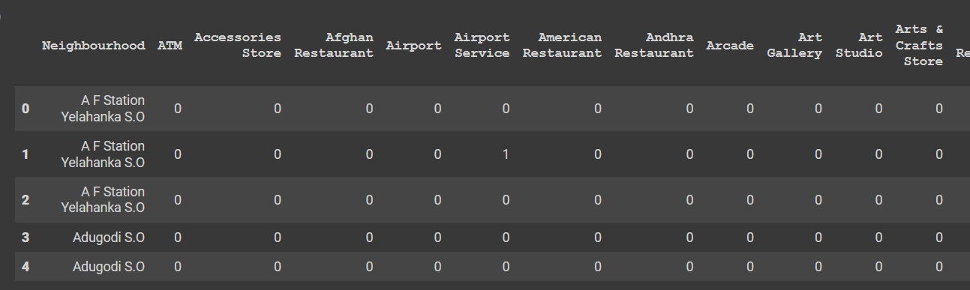

We changed it to one-hot encoding since we need to make a prediction for where the most common venue will be for clustering the labels. As a result, the category table has been transformed to a one-hot encoded format.

After that, we'll use the function generated in the code to discover the places with the most common venue, and we'll obtain Bangalore.

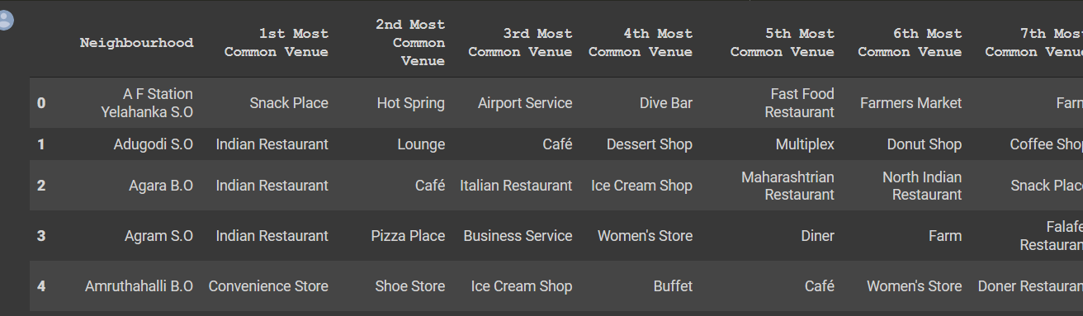

**Clustering**

Following the preceding stage, we must determine the K value for the K-mean Clustering algorithm's clustering analysis. As a result, we'll use the silhouette technique to get the best k-value. For the Bangalore data set, the optimum value for the K will be 3, We'll figure it out by plotting it on a graph, as illustrated.

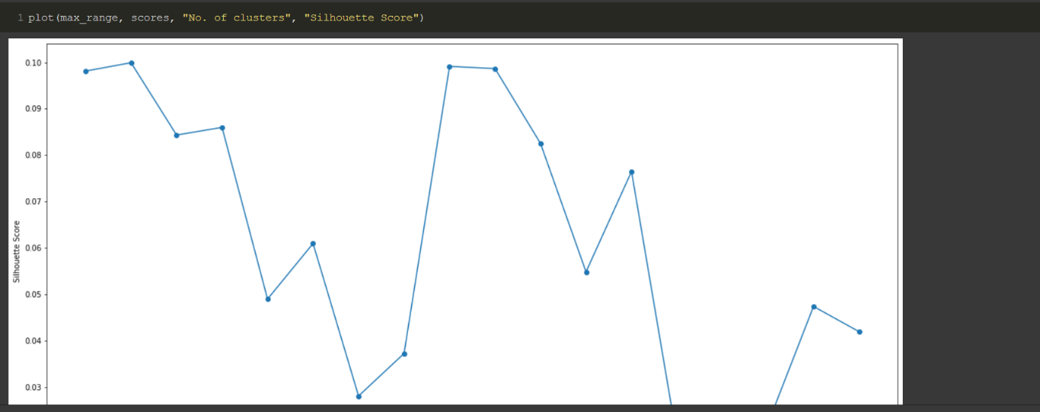

Now, analysing with k-means clustering

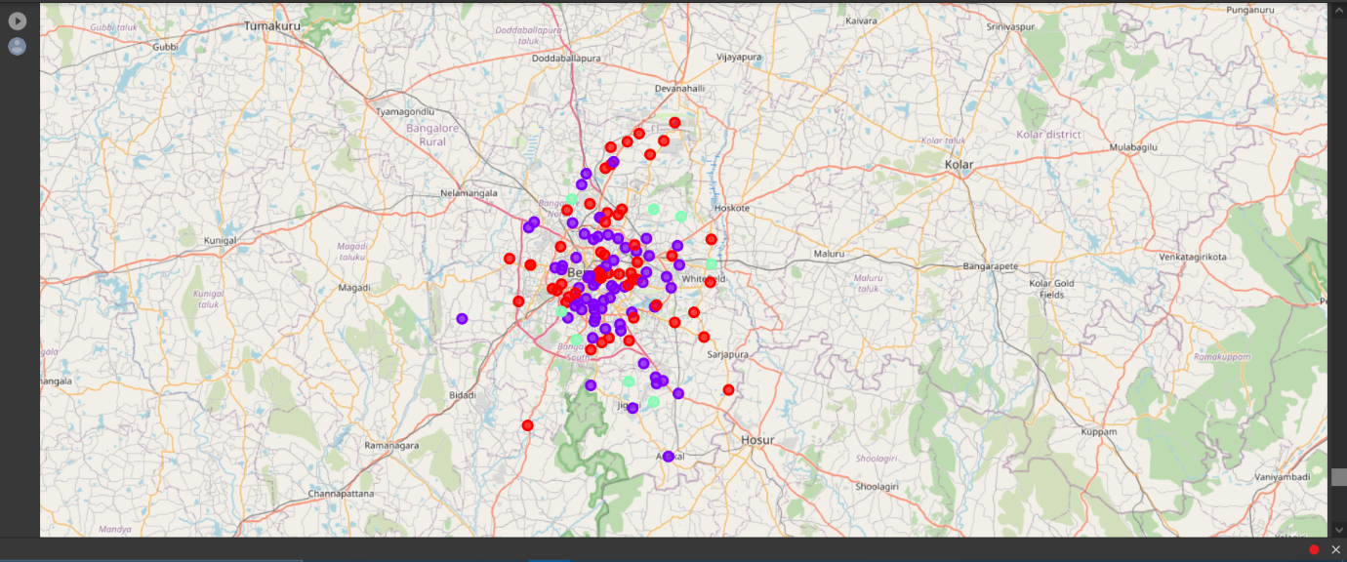

Because the places are so close to each other and the recommended venue is so high in those areas, the cluster labels for Bangalore may go up to 2

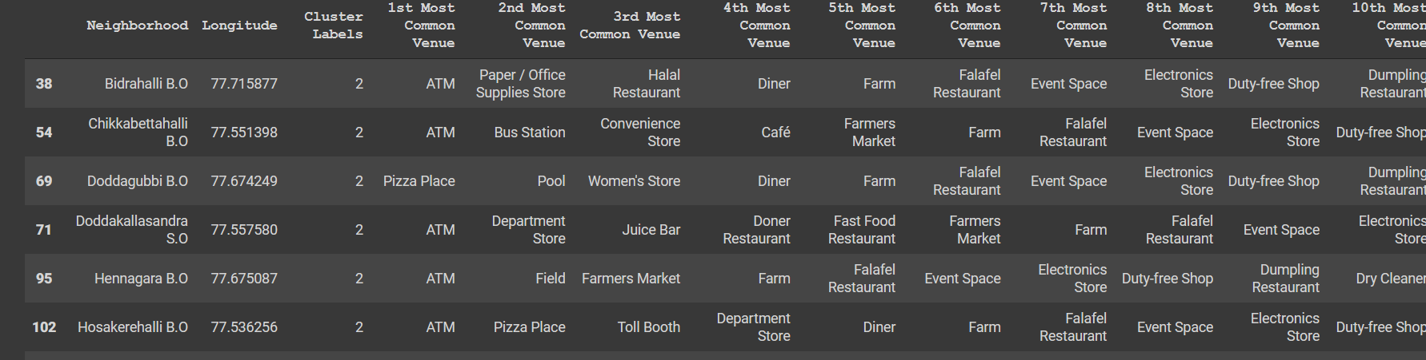

**Result**

According to the above analysis, the best place to start to live in Bangalore are Bidrahalli, Chikkabettahalli, Doddagubi, Doddakallasandra, Hennagara, Hosakerahalli, Hulimangala and Kadugodi.